

School of Informatics & IT

Database Application Development (45%)
Application Development Project (35%)
(Web Application Design + Database Design)
AY 25/26 Oct Semester
Project 1 Report

Contents
Declaration of Originality 3
DBAV: Database Design (45%) 6
Section A: Website Proposal (5%) 6
Section B: Interview Findings (5%) 7
Section C: Entities (5%) 8
Section D: Data Dictionary (10%) 9
Section E: ERD and Relationships (10%) 10
Section F: Normalisation (10%) 11
ADEV: Web Application Design (30%) 12
Section G: Implementation, Design & Layout (15+5%) 12
Section H: Justification (10%) 13

SCHOOL OF INFORMATICS & IT

Diploma in Information Technology

Project 1 Report

Student Name (Matric Number) :Leon Jr Chua

Tutorial Group : TC23
Jenny LING (TP)
Tutor : Mr Alfred Teng

Submission Date : 7/12/2025

Declaration of Originality

I am the originator of this work and I have appropriately acknowledged all other original sources used as my references for this work.

I understand that Plagiarism is the act of taking and using the whole or any part of another person’s work, including work generated by AI, and presenting it as my own.

I understand that Plagiarism is an academic offence
and if I am found to have committed or abetted the offence of plagiarism in relation to this submitted work, disciplinary action will be enforced.

Declaration on the use of Generative AI tools for assignments

Describe how you have used Generative AI tools such as ChatGPT or Dall.E- in your assignment.

Share the link to the conversations you had with the AI tool (i.e., the prompts you used and the responses you get from the AI tool).

Please refer to this PDF on “How to share the conversations made with ChatGPT?”

https://chatgpt.com/share/693505f1-3bf4-8012-97f7-6c9d6710bcf0

How do you indicate the reference?
The content generated by AI tools are not retrievable except by the user who generated them, so they are considered non-recoverable sources. Although non-recoverable data or quotations in APA Style papers are usually cited as personal communications, with ChatGPT-generated text there is no person communicating. Quoting text from ChatGPT chat is therefore more like sharing the output of an algorithm, with a reference list entry and the corresponding in-text citation.
According to the official APA Style site, ChatGPT references should be cited as:
E.g. OpenAI. (2024). ChatGPT (Feb 13 version) [Large language model].
https://chat.openai.com/chat

Note: The information in parentheses refers to the update or revision date of the model used. Refer to the release notes in the ChatGPT application.

Important Note:

- Do not copy answers produced by the AI tool in totality as it is considered as plagiarism.

- Do not rely on any information produced by the AI tool blindly. You should always verify the answer with other sources. Do not assume that these answers provided by the AI tool are correct.

- To achieve quality outputs from the AI tool, you should provide good prompt that is clear and specific. Be precise and provide context. Avoid asking open-ended questions.

DBAV Part 1: Database Design (45%)

Section A: Website Proposal (5%)
Ensure that your website proposal covers the following points:

Proposed online website idea | IIT Q&A forum  IIT students can post questions seeking for help/guidance, provide and vote on helpful and informative responses that they like in turn receiving XP (experience points) that can help them level up and earn SEAL points
Purpose | Students can get help with assignments like coding or math, clarify hard to grasp topics and share useful knowledge on this platform for all other students. The XP system can help incentivise students to contribute more by rewarding students that actively help others with SEAL points. The website also acts as a library full of solutions of previous work allowing new students to find answers on their own and reducing repetitive questions that lecturers get asked.
How it will enhance the experience of the IIT students | It will provide a supportive community for students in IIT. Instead of struggling alone, students can post questions on various topics such as coding, math and different concepts from other modules getting help and feedback from other IIT students that have faced or are facing the same problems. This in turn can build a stronger sense of community among IIT students.
The need and demand for such an online website | Many IIT students struggle to find help for their assignments or project work outside of class hours, even with generative AI, the answers given may not be relevant to what is needed. Having this centralised Q&A and community forum can help provide more accessible knowledge to students. This also supports self directed learning which ties into one of the skills that TP students are taught.

Section B: Interview Findings (5%)
Interview 5 (FIVE) IIT students to identify what kind of features they would want in the online website.

Student name & email | Desired feature
Ian  2501272E@student.tp.edu.sg | I would like to see filters for the website forum area so I can easily filter by subject/module and find answers easily without having to scroll through a lot .
Hannan  2500881D@student.tp.edu.sg | Profiling feature where it can show the students XP/rank and earned seal points. It can also display the upcoming milestones to be reached
Kyle  2500309F@student.tp.edu.sg | Maybe like a “study corner” area on the website where students can go to do focus on their work, the page would be something minimalist like to avoid distractions so maybe just a clock and timer plus a simple background, it could also include a ‘radio’ where calming songs could be turned on and off.
Anis  2504448H@student.tp.edu.sg | A search bar that allows students to quickly find relevant answers/ questions
Adiel  2502242G@student.tp.edu.sg | Voting system to allow students to Upvote or Downvote on posts, this allows the best/most useful questions to be more seen.
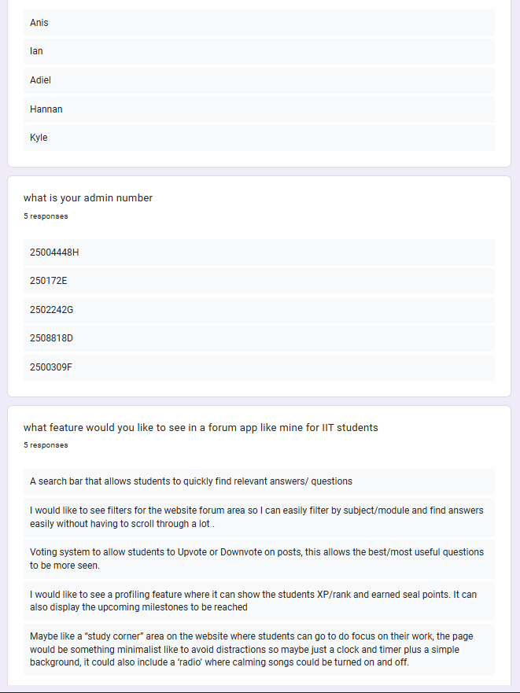
Provide an insightful summary on the interview findings, listing all the features you would like to include in your proposed website:
From the interviews conducted I can see that majority of students wanted a clear, organised and easy to navigate website. Students highlighted the need for filters and search bars which would allow them to quickly find the relevant questions or answers that they are looking for, this highlighted a pain point for them where students lack time and struggle to locate relevant help. Subject filters address this by reducing information overload while keyword searching help students find more specific questions related to what they are finding.
Additionally, one student wished for a profile feature where they could see their own progress in terms of XP level and Seal points gained, this can help motivate students to contribute useful answers
Lastly a voting system was requested, this can help users upvote or downvote answers. This helps students quickly identify which answers are trustworthy.
Based on the interview, I would like to include,
Search Bar,
Subject/Module filters,
voting system
profile system
These five features creates a place where students can independently discover solutions, easily evaluate answer quality and contribute with recognition- directly supporting my project goal of providing accessible community-driven knowledge-sharing outside of class hours.

Section C: Entities (5%)
Identify 4 (FOUR) to 6 (SIX) entities that will be required. The entities identified must meet all the requirements of the website proposed in Section A/B and have a clear purpose.
Entities | Reasoning for including it
User information | User information is needed to store attributes such as user id, name, Seal points/XP. These are essential to track and maintain contributions to the right profile such as posting useful answers. By having this entity I can ensure that Seal points and XP levels get granted to the correct profiles.
Question | For question entity, attributes such as topic, answer, author and timestamp are all needed so that the question can be filtered easily such as by topic or recency. Question helps ensure that the right answers are connected to the respective question and also helps accurately reward the student that contributed the useful answer.
Answer | The answer entity is needed because a question may have multiple answers, having an answer entity allows the system to know who answered and when it was answered assisting with the filter feature, voting the XP allocation/Seal points reward system. This allows the system to properly show and ranked XP/rewards for individual answers.
Level | Level entity is needed so that users will be linked directly to their current level and see their progress towards the next level as well as the upcoming rewards. This entity also allows users to track their seal points earned.
Vote | Vote entity is needed to properly track votes made by other users(upvote or downvote) on answers they find useful/not useful, the vote entity also helps prevent duplicate votes and is key in the Seal points and Xp system for ranking answers.
Subject | Subject entity is needed so that each question can be categorised to its specific module. This helps student filter based on the subject/project that they want and find the most relevant materials quickly thus supporting the search and filter feature in section B

Section D: Data Dictionary (10%)
For each entity listed in Section C, list at least 2 (TWO - minimum) to 5 (FIVE - maximum) relevant attributes.

Table Name: User
Description: Stores user account information such as Email password and name. Includes XP_points to help track Seal point allocation, it also shows current level for users to check their progression.
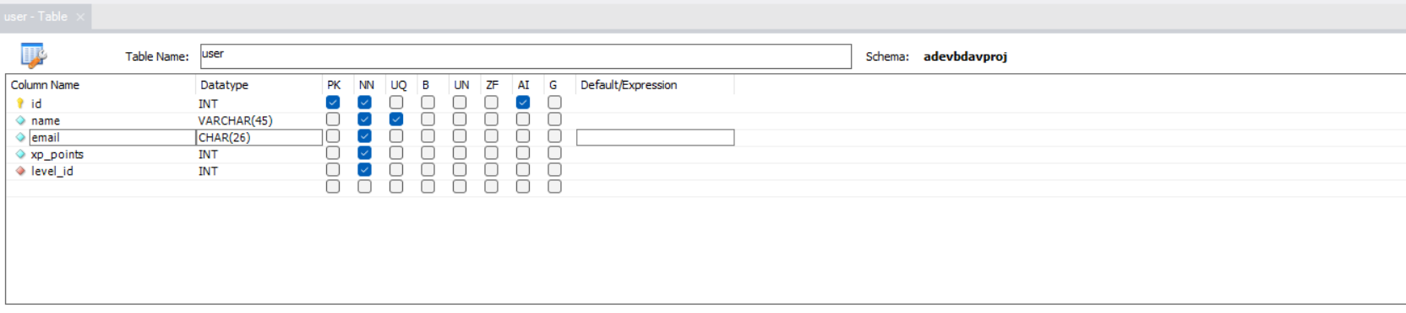

Field Name | FK  (Parent Table Name) | Example | Justification
id | - | 1 | An auto-incrementing ID ensures that each new user automatically receives a unique identifier
name | - | Jane Doe | Stores user full name to display in profile and for answers/questions
email | - | Janedoe6162@students.edu.tp.sg | Email is needed for account verification and to make sure there can be no duplicate accounts. It has unique constraint to prevent duplicate accounts under the same email
xp_points | - | 670 | Tracks xp points earned by user by providing helpful answers and receiving upvotes, used to determine account level and Seal points earned
level_id | level | 6 | Level_id is a foreign key linking user to current level, helps with tracking progress and displaying level info in their profile.

Table Name: level
Description: determines experience level milestones and rewards for user progression (eg 100xp = bronze level)
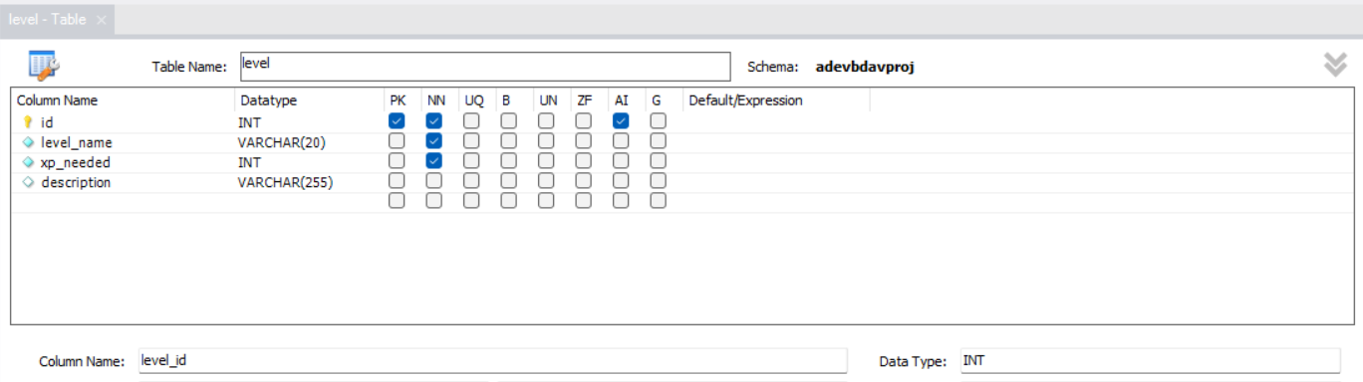

Field Name | FK  (Parent Table Name) | Example | Justification
id | - | 1 | An auto-incrementing ID ensures that each level receives a unique identifier.
level_name | - | diamond | Stores a level name that helps indicate user progression level
xp_needed | - | 1000 | Stores the value of how much xp is needed to attain this level
description | - | Provided 10 helpful answers or received 50 total Upvotes | stores level description showing users what actions they need to do before being able to attain this level

Table Name: vote
Description: tracks individual votes made by users on answers, this prevents duplicate votes and helps with accurately ranking helpful answers.
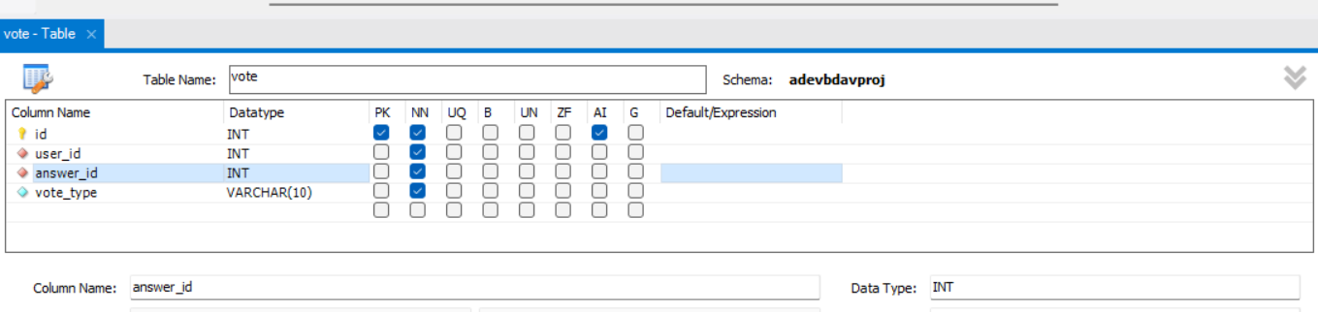

Field Name | FK  (Parent Table Name) | Example | Justification
id | - | 1 | An auto-incrementing ID ensures that each vote receives a unique identifier.
User_id | user | 6 | Foreign key that Links vote to the user that made the vote, prevents duplicate voting from the same user.
Answer_id | Answer | 7 | Foreign key that Links vote to the answer that is being voted on.
Vote_type | - | Upvote | stores type of vote ‘upvote’ or ‘downvote’, used to calculate vote counts and rank answers by helpfulness by comparing number of upvotes and downvotes.

Table Name: subject
Description: list of subject/modules that questions can be categorized under for easy navigation and the filter feature.
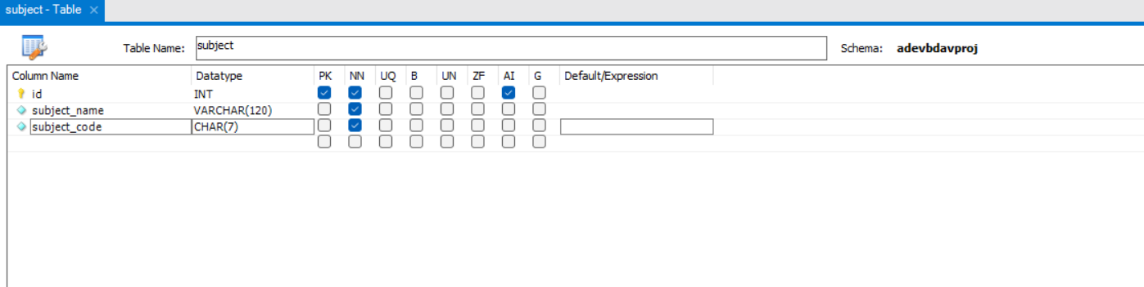

Field Name | FK  (Parent Table Name) | Example | Justification
id | - | 5 | An auto-incrementing ID ensures that each subject receives a unique identifier.
Subject_name | - | Computational Thinking | Stores full name of subject/module
Subject code | - | CMT6162 | Stores the subject code for easy identification and reference by students.

Table Name: question
Description: Stores questions posted by users on the forum such as content, subject_id and time_of_post which helps with filtering and searching.
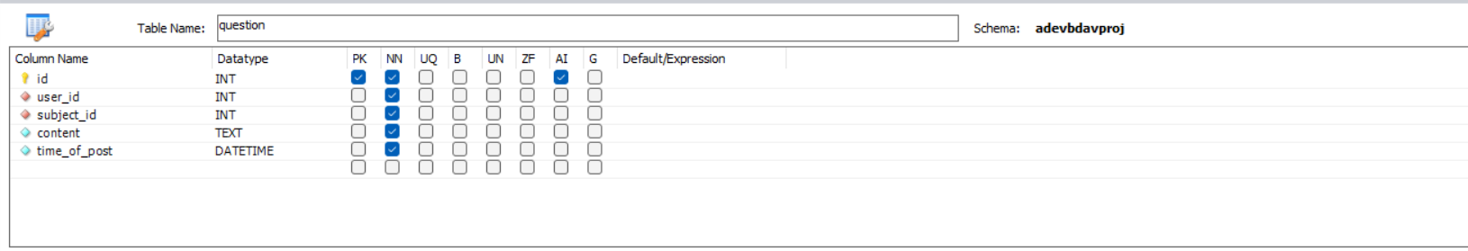

Field Name | FK  (Parent Table Name) | Example | Justification
id | - | 6 | An auto-incrementing ID ensures that each question automatically receives a unique identifier
user_id | user | 61 | Foreign key that Links question to user that posted it
Subject_id | subject | 7 | Foreign key that links question to specific subject/module, enables the filtering and categorisation.
content | - | Im not so sure when while loop is more useful as compared to for loops or when to use one over the other. | Stores the question content, allow for longer more detailed questions and content for answers to be more relevant and helpful. When searching keywords, system can scan the content for the same words to get relevant questions making it easier to find help.
Time_of_post | - | 2025-11-9 20:36:10 | Timestamp for when the question was posted, allows for sorting by recency.

Table Name: answer
Description: stores answers provided by users in response to questions with tracking of votes
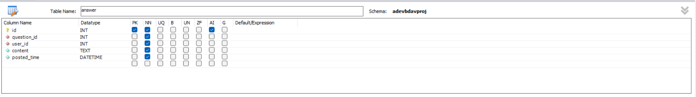

Field Name | FK  (Parent Table Name) | Example | Justification
id | - | 2 | An auto-incrementing ID ensures that each answer automatically receives a unique identifier
question_id | Question | 6 | Foreign key that Links answer to its respective question, ensures that answers are linked to the correct question
user_id | user | 9 | Foreign key that links answer to the user that posted it, tracks user contribution and enables XP/seal point allocation
content | - | You can use a for loop like this:  for I in range(10): … | Stores the answer content which contains the helpful information that students are looking for.
Posted_time | - | 2025-11-10 09:30:56 | Timestamp for when the answer was posted, allows for sorting by recency.

Section E: ERD and Relationships (10%)
Paste a screenshot of your Entity-Relationship Diagram in this section.
Please make your screenshot image are sharp and clearly shown all the attributes and their data type for each entity.
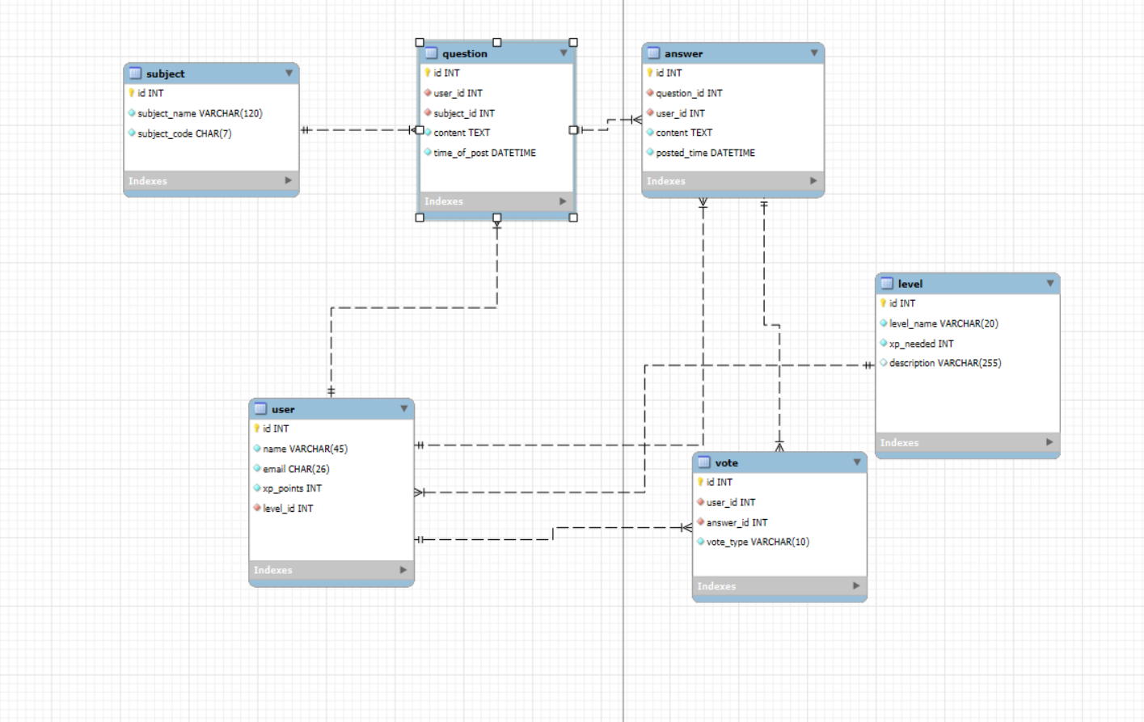

For each relationship, identify the entities involved and explain clearly the rationale of the relationship in terms of meeting the requirements of the proposed online website in Task 1

Entity 1 | Entity 2 | Relationship | Justification
user | vote | One to many | One user can cast multiple votes on different answers, but each vote can only be made by one user. This prevents duplicate voting by tracking which user made what vote
user | level | Many to one | Many users can be the same level, but a user can only be at one level at a time. This allows the system to check user progression and display their level information on their profile page correctly.
user | Answer | One to many | A user can provide multiple answers but each answer only belongs to one user. This helps with proper allocation of seal points/xp to the correct student that provided the helpful response.
user | question | One to many | A user can post multiple different questions but each question can only belong to one user. This helps tracks which student posted what question.
Subject | Question | One to many | One question can only be linked to one subject but one subject can have many questions. This supports the filtering feature requested
Question | Answer | One to many | One question can have multiple answers but each answer only replies to one question. This ensures the correct answers can be displayed under their respective questions and be displayed correctly for other users to vote based on helpfulness
Answer | Vote | One to many | One answer can receive multiple votes from different user but each vote applies to only one answer. This enables the voting/ranking system that helps surface the more helpful questions as feature that was requested during the interview.

Section F: Normalisation (10%)
Write a report of no more than 300 words on how you address the following issues:
- How does your design prevent insertion anomalies?
- How does your design prevent update anomalies?
- How does your design prevent deletion anomalies?
Include significant examples to illustrate how your design addresses each anomaly.
Insertion anomalies:
In the design, it prevents insertion anomalies using foreign keys and properly separating entities. For example, the subject entity was made so that it can new subjects can be added into the database without it needing questions to be posted first.

Without normalisation, if subject information like subject _name and subject_code were attributes in the question table, it would be impossible to add a new subject without having to create a question. Eg if I wanted to add a subject ‘UXID’ I would have to create a placeholder question to satisfy the requirements for adding a record. Having the subject table allows me to add new subjects without it depending on questions.
Update anomalies:
In the design update anomalies are prevented by removing data redundancy through normalisation, for example, subject_name was stored with subject_code and subject_id instead of being stored in the question table.
Without normalisation and storing of subject_name in the subject table, if subject_name was store in question and I were to edit the name of a existing subject for example ‘data structure and algorithm’ to ‘Data and algorithm’ the update would need to be applied to all questions under that subject however with my design the update would only one update is needed in the subject table only
Deletion anomalies:
In the design, deletion anomalies were prevented by normalising the database and placing subjects into their own subject table such that if questions were deleted the subject details would remain.
Without the design if subject details were stored inside question_info table, deleting the last question under a subject e.g ‘LeadFun’, it would also remove the subject thus causing the loss of related data that was important.
With the normalised database in my design, deleting a question does not affect the subject as it is stored independently in separate table

ADEV: Web Application Design (30%)

Section G: Implementation (15%), Design & Layout (5%), Justification (10%)

Include screenshots of each page implemented under this section. Clearly label each page name. Explain and justify the HTML design choices you made in your implementation. Your explanation should describe how the selected HTML elements support the structure and requirements of your ER diagram submitted under Task 4, why they are suitable for presenting the application’s data and functionality, and how they contribute to usability for the intended users.

Home page
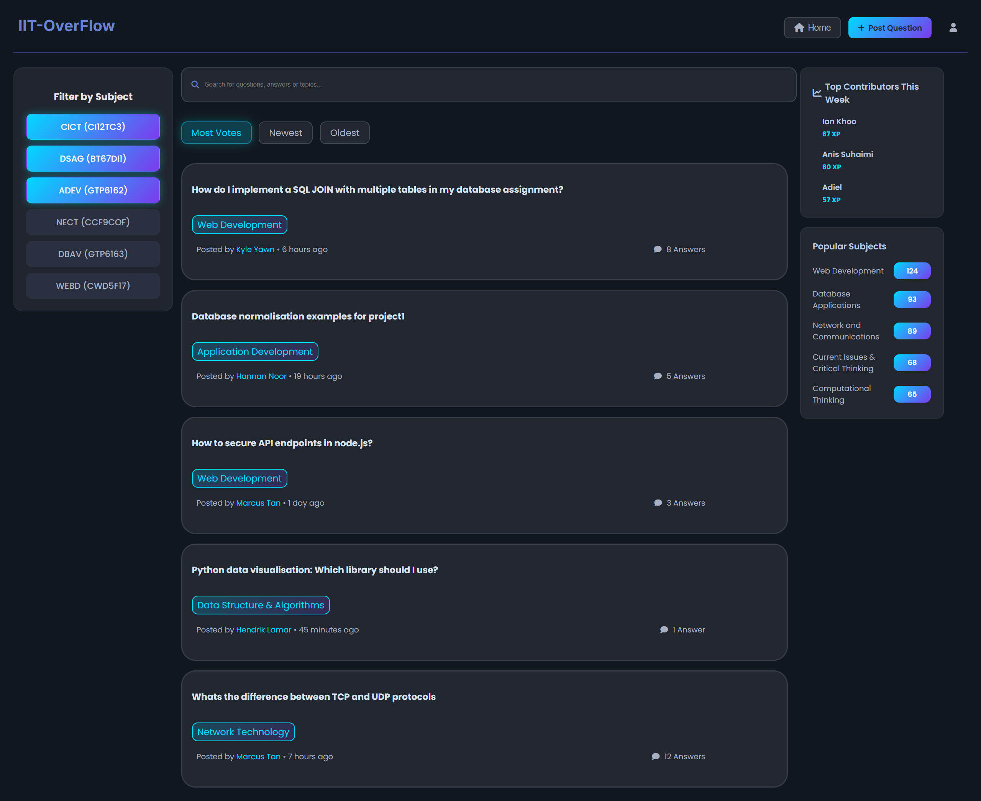
home_page.html

The home page uses a 3-column grid layout, to support efficient navigation and to show the data relationships in the ER diagram. The left sidebar displays subject filters using <input type=’checkbox’> + <label> elements, reflecting subject entity. The centre column displays question cards showing question entity attributes (title, content, timestamps) linked to Users via author name (question-to-user one to many relationship).
The search bar use semantic <input type=’text’> for keyword searching across question entity content, allowing students, below search bar there are radio and checkbox inputs to allow user to sort by relevance, enabling for flexible sorting.

The right sidebar displays Top contributors using user entity with calculated XP from answers and votes relationship, this helps student quickly identify reputable community members. The design choices addresses interview findings, Ian requested subject filtering for easy navigation and Anis asked for quick search functionality.

Profile page
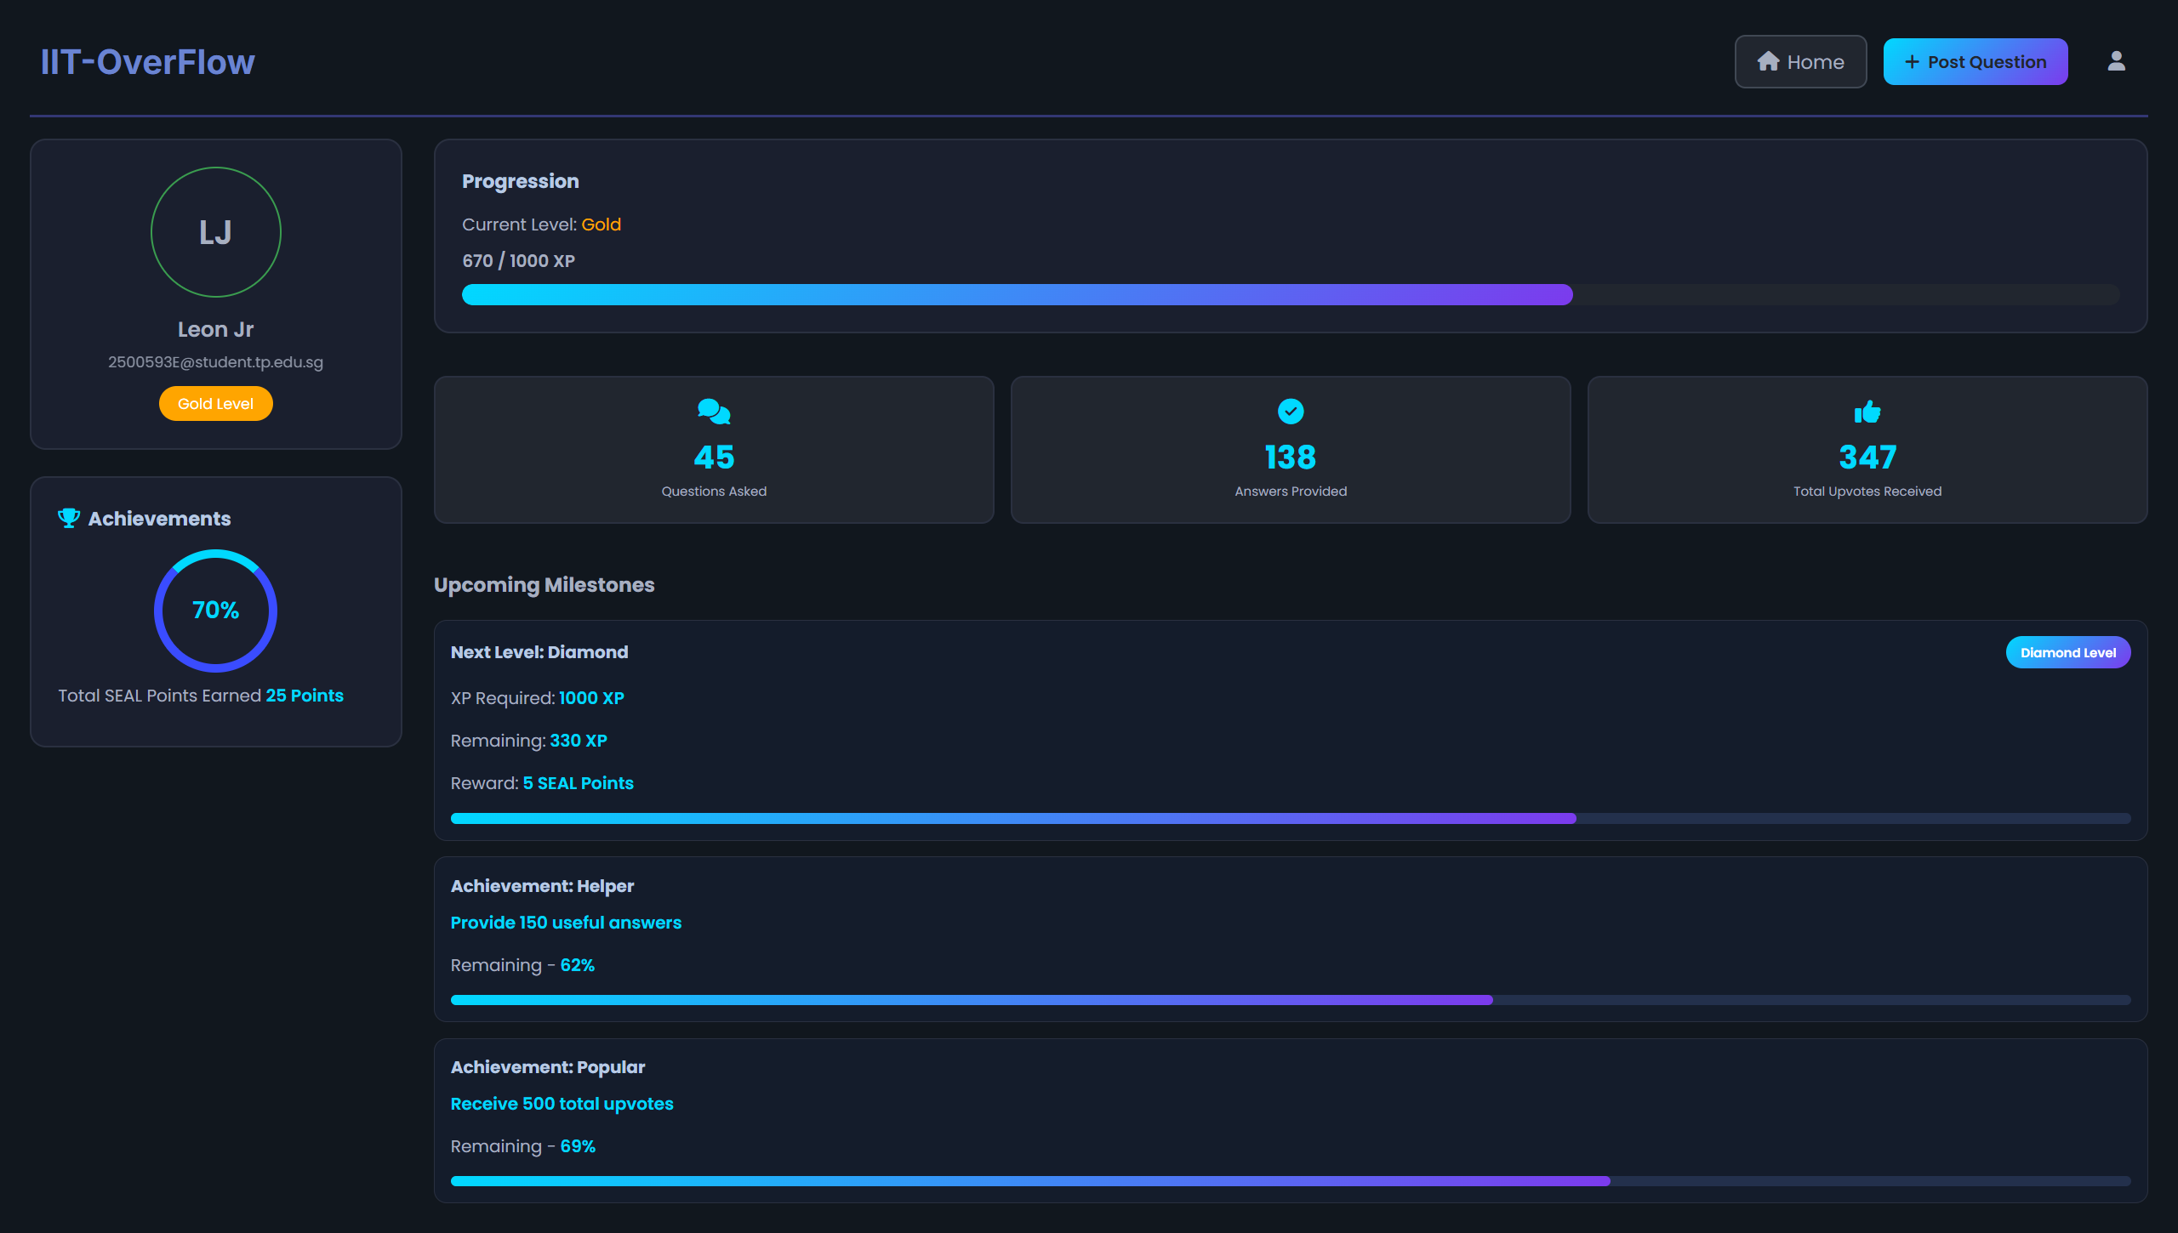
Profie_page

The profile page displays user entity attributes (name, email, xp) and level which is linked to level entity implementing the user-to-level many-to-one relationship. A progress bar uses semantic HTMK structure to show XP-needed attribute, displaying xp progress towards level milestones. It also shows total SEAL points earned helping students track their rewards.
Statistic cards display metrics such as question count, answer count, upvote count (calculated from vote entity). These metrics help motivate students by showing their contribution and value.
Milestone progress trackers display upcoming goals using the same XP mechanics for some goals (reaching diamond level), this directly addresses Hannan’s interview requirement of showing students xp/rank and seal points with upcoming milestones.
All together, the profile design supports the project goal of incentivising contribution through gamification. Visible progression, statistics and milestone tracking help motivate students to contribute quality answers enabling my goal of a self-directed community-driven knowledge sharing platform.

Post question page
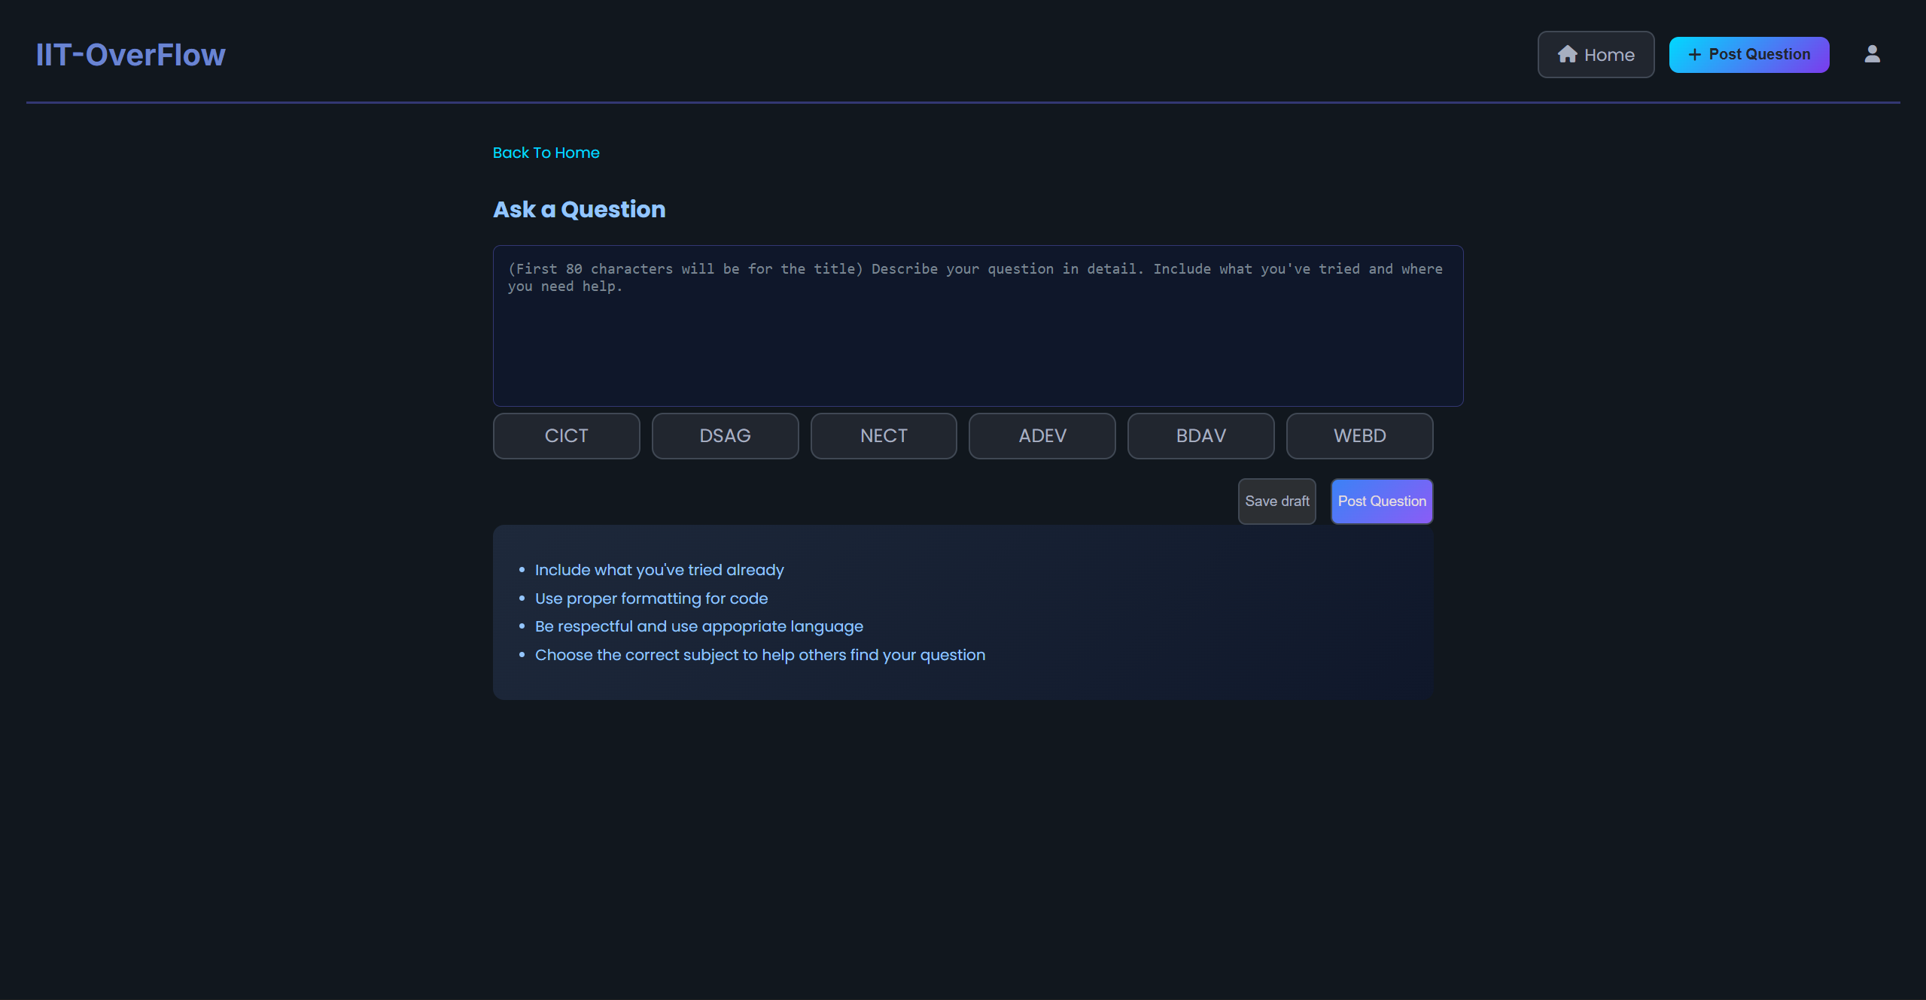
Post_question_page.html

The post question page uses semantic <form> element to collect question entity data, a textarea element is used to capture content, it has a placeholder text guiding users to format titles within the first 80 characters.
Subject selection uses semantic <input type=’radio’> and <label> elements making sure that each question links to exactly one subject entity (question-to-subject) many-to-one relationship. Using radio buttons prevents situations where a question could be mistakenly linked to multiple subject.
The tips box uses <ul> and <li> elements provides guidance on question quality by setting a community standard. ‘save draft’ and ‘post question’ button allows for multiple workflows and allowing students to come back to their question to complete at a later time.
A back-navigation link improves efficiency allowing students to return to home easily.
Combined, these design choices directly support the project goal of enabling self-directed help-seeking.

Question detail page
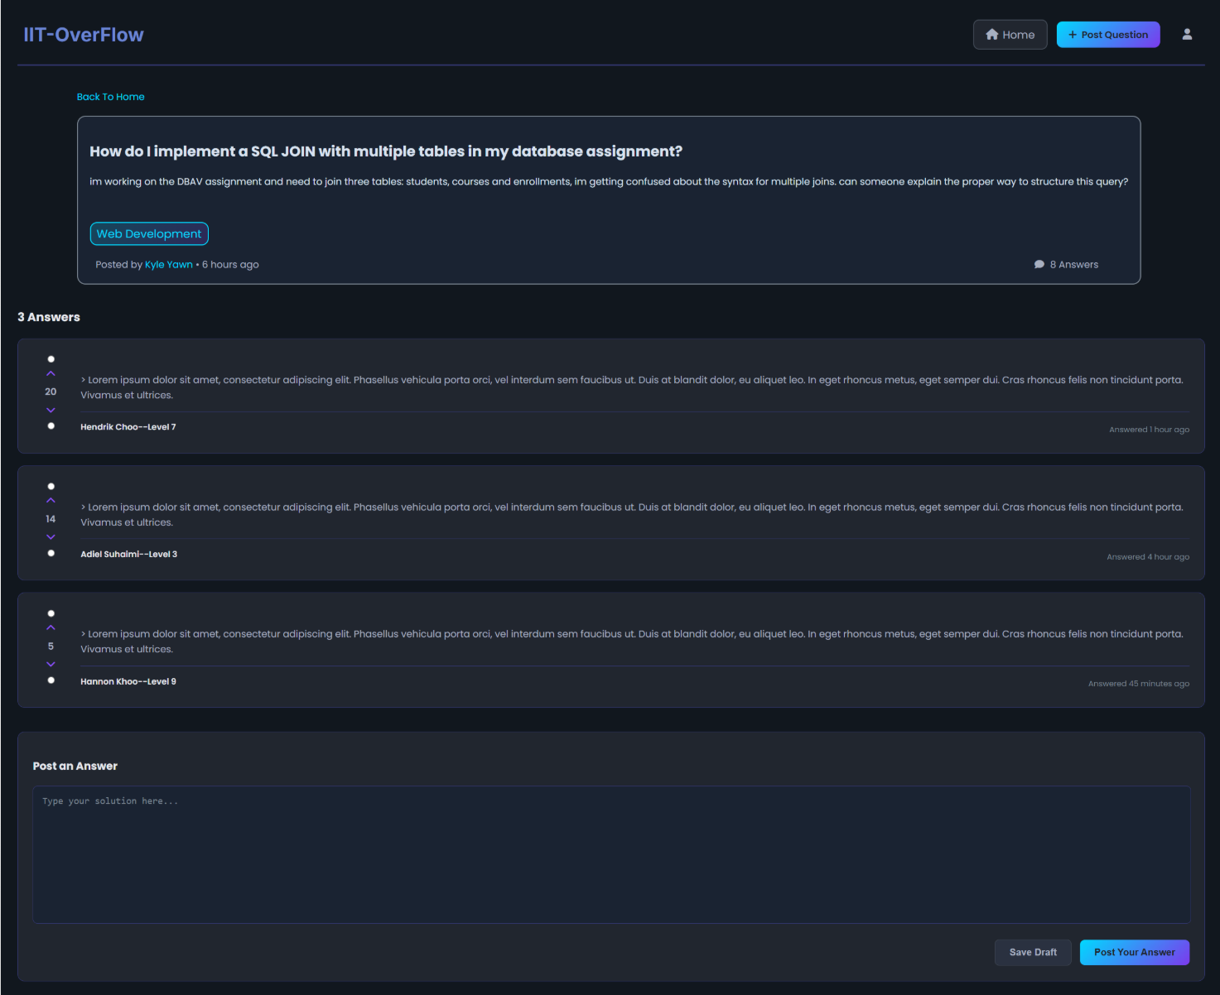

Question_detail_page.html

The question detail page displays almost the entire question entity as well as the associated answers through semantic html structure, the question content uses <h2> and <p> ,showing question entity attributes (subject, content, time of post, author).
Each answer is displayed in a <div> container showing the Answer entity content. The answer displays author name and level, linking the answer to its user. Vote buttons use <input type=”radio”> elements therefore only allowing user to either upvote or downvote, votecount is displayed next to the button allowing students to identify well liked solutions that the community approves of.
An answer form using semantic <form> and <textarea> enables creation of new Answers (new answer entity record) while ‘save draft’ and ‘post your answer’ supports multiple workflows.
This design supports the project goal of helping students find trustworthy answers by showing author reputation level and vote count, students can easily identify useful solutions

